DATABASE DESIGN
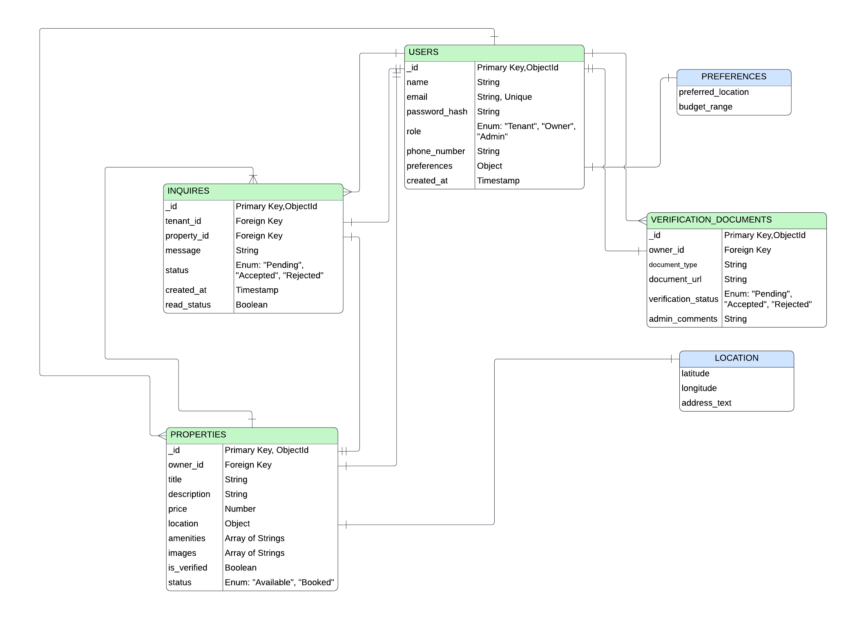
Schemes for Mongoose:

1. User Schema (models/User.js)
Handles Tenants, Owners, and Admins.
Schema:
const mongoose = require('mongoose');
const userSchema = new mongoose.Schema({
name: {
type: String,
required: true,
trim: true
},
email: {
type: String,
required: true,
unique: true,
lowercase: true,
trim: true
},
password_hash: {
type: String,
required: true
},
role: {
type: String,
enum: ['Tenant', 'Owner', 'Admin'],
default: 'Tenant',
required: true
},
phone_number: {
type: String,
required: true
},
preferences: {
budget_range: {
min: { type: Number, default: 0 },
max: { type: Number }
},
preferred_location: {
type: String,
trim: true
},
looking_for: {
type: String,
enum: ['PG', 'Flat', 'Room', 'Any'],
default: 'Any'
}
}
}, { timestamps: { createdAt: 'created_at', updatedAt: 'updated_at' } }),
module.exports = mongoose.model('User', userSchema);

2. Property Schema (models/Property.js)
Stores listing details.
Schema:
const mongoose = require('mongoose');
const propertySchema = new mongoose.Schema({
owner_id: {
type: mongoose.Schema.Types.ObjectId,
ref: 'User',
required: true
},
title: {
type: String,
required: true,
trim: true
},
description: {
type: String,
required: true
},
price: {
type: Number,
required: true
},
property_type: {
type: String,
enum: ['PG', 'Flat', 'Independent House'],
required: true
},
location: {
type: {
type: String,
enum: ['Point'],
default: 'Point'
},
coordinates: {
type: [Number],
required: true
},
address_text: {
type: String,
required: true
}
},
amenities: [{
type: String
}],
images: [{
type: String
}],
is_verified: {
type: Boolean,
default: false
},
status: {
type: String,
enum: ['Available', 'Booked'],
default: 'Available'
}
}, { timestamps: { createdAt: 'created_at', updatedAt: 'updated_at' } });
propertySchema.index({ location: '2dsphere' });
module.exports = mongoose.model('Property', propertySchema);

3. Inquiry Schema (models/Inquiry.js)
Handles the communication bridge.
Schema:
const mongoose = require('mongoose');
const inquirySchema = new mongoose.Schema({
tenant_id: {
type: mongoose.Schema.Types.ObjectId,
ref: 'User',
required: true
},
property_id: {
type: mongoose.Schema.Types.ObjectId,
ref: 'Property',
required: true
},
message: {
type: String,
required: true
},
status: {
type: String,
enum: ['Pending', 'Accepted', 'Rejected'],
default: 'Pending'
},
read_status: {
type: Boolean,
default: false // Used for notification badges
}
}, { timestamps: { createdAt: 'created_at', updatedAt: 'updated_at' } });
module.exports = mongoose.model('Inquiry', inquirySchema);

4. Verification Document Schema (models/VerificationDocument.js)
Handles the anti-fraud logic.
Schema:
const mongoose = require('mongoose');
const verificationSchema = new mongoose.Schema({
owner_id: {
type: mongoose.Schema.Types.ObjectId,
ref: 'User',
required: true
},
document_type: {
type: String,
enum: ['Aadhar Card', 'Property Deed', 'Electricity Bill'],
required: true
},
document_url: {
type: String, // Secure Cloudinary URL
required: true
},
verification_status: {
type: String,
enum: ['Pending', 'Approved', 'Rejected'],
default: 'Pending'
},
admin_comments: {
type: String, // Reason for rejection, if any
default: ''
}
}, { timestamps: { createdAt: 'created_at', updatedAt: 'updated_at' } });
module.exports = mongoose.model('VerificationDocument', verificationSchema);

